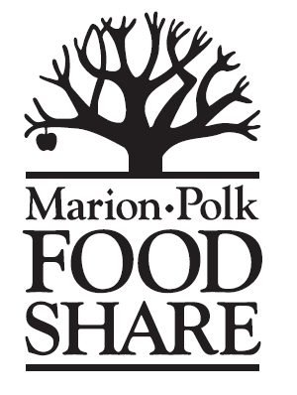
COMMUNITY GARDEN VOLUNTEER
LIABILITY RELEASE FORM
TO BE READ AND SIGNED BY ALL GROUPS INTENDING
TO VOLUNTEER FOR MARION-POLK FOOD SHARE IN A COMMUNITY GARDEN

In connection with my voluntary involvement in activities undertaken for, and with the participation and support of Marion-Polk Food Share, I hereby agree, for myself, my heirs, assigns, executors, and administrators to release and discharge Marion-Polk Food Share, its officers and directors, employees, agents, and volunteers from all claims, suits, demands, and actions for injuries and/or loss sustained to my person and/or property as a result of my involvement in such activities, including any claims based upon negligence. I hereby attest that my attendance and involvement in such activities is voluntary, that I am participating at my own risk, and that I have read the foregoing terms and conditions of this release. In addition, I agree that I will maintain any required licenses if I am assigned a volunteer activity requiring such licenses, and that I will comply with all applicable federal, state, and local laws while serving as a volunteer for Marion-Polk Food Share.

NAME OF GROUP/ORGANIZATION:____________________________________________________

DATE(S) and TIME OF ACTIVITY:_______________________________________________________

LOCATION OF ACTIVITY: _____________________________________________________________

CONTACT PERSON:_____________________________________PHONE:______________________

EMAIL:____________________________________________________________________________

SUPERVISOR(S) PRESENT FOR GROUP ACTIVITY:

_________________________ _________________________ _________________________
(Please print clearly) (Please print clearly) (Please print clearly)

Volunteer Name (print) Volunteer Signature Date

Volunteer Name (print) Volunteer Signature Date

Volunteer Name (print) Volunteer Signature Date

Volunteer Name (print) Volunteer Signature Date

Volunteer Name (print) Volunteer Signature Date

Volunteer Name (print) Volunteer Signature Date

Volunteer Name (print) Volunteer Signature Date

Volunteer Name (print) Volunteer Signature Date

Volunteer Name (print) Volunteer Signature Date

Volunteer Name (print) Volunteer Signature Date

Volunteer Name (print) Volunteer Signature Date

Volunteer Name (print) Volunteer Signature Date

Volunteer Name (print) Volunteer Signature Date

Volunteer Name (print) Volunteer Signature Date

Volunteer Name (print) Volunteer Signature Date

Volunteer Name (print) Volunteer Signature Date

Volunteer Name (print) Volunteer Signature Date

Volunteer Name (print) Volunteer Signature Date

TOTAL VOLUNTEERS: ________________ TOTAL VOLUNTEER HOURS: ______________

Please return completed form to Leana at Marion-Polk Food Share:
1660 Salem Industrial Drive NE Salem, OR 97301
ldickerson@marionpolkfoodshare.org

